# Rossmoyne Senior High School

### Year 12 Trial WACE Examination, 2015

### Question/Answer Booklet

If required by your examination administrator, please place your student identification label in this box

# MATHEMATICS

# 3AB

## Section Two:

## Calculator-assumed

|  |  |  |  |  |  |  |  |  |
| --- | --- | --- | --- | --- | --- | --- | --- | --- |
| Student Number: In figures |  |  |  |  |  |  |  |  |

In words

Your name

## Time allowed for this section

Reading time before commencing work: ten minutes

Working time for this section: one hundred minutes

## Materials required/recommended for this section

##### *To be provided by the supervisor*

This Question/Answer Booklet

Formula Sheet (retained from Section One)

##### *To be provided by the candidate*

Standard items: pens (blue/black preferred), pencils (including coloured), sharpener,

correction fluid/tape, eraser, ruler, highlighters

Special items: drawing instruments, templates, notes on two unfolded sheets of A4 paper, and up to three calculators approved for use in the WACE examinations

## Important note to candidates

No other items may be taken into the examination room. It is **your** responsibility to ensure that you do not have any unauthorised notes or other items of a non-personal nature in the examination room. If you have any unauthorised material with you, hand it to the supervisor **before** reading any further.

## Structure of this paper

|  |  |  |  |  |  |
| --- | --- | --- | --- | --- | --- |
| Section | Number of questions available | Number of questions to be answered | Working time (minutes) | Marks available | Percentage of exam |
| Section One:  Calculator-free | 7 | 7 | 50 | 50 | 33⅓ |
| Section Two:  Calculator-assumed | 13 | 13 | 100 | 100 | 66⅔ |
|  | | | **Total** | 150 | 100 |

## Instructions to candidates

1. The rules for the conduct of examinations are detailed in the school handbook. Sitting this examination implies that you agree to abide by these rules.
2. Write your answers in this Question/Answer Booklet.
3. You must be careful to confine your response to the specific question asked and to follow any instructions that are specified to a particular question.
4. Spare pages are included at the end of this booklet. They can be used for planning your responses and/or as additional space if required to continue an answer.

* Planning: If you use the spare pages for planning, indicate this clearly at the top of the page.
* Continuing an answer: If you need to use the space to continue an answer, indicate in the original answer space where the answer is continued, i.e. give the page number. Fill in the number of the question that you are continuing to answer at the top of the page.

1. **Show all your working clearly**. Your working should be in sufficient detail to allow your answers to be checked readily and for marks to be awarded for reasoning. Incorrect answers given without supporting reasoning cannot be allocated any marks. For any question or part question worth more than two marks, valid working or justification is required to receive full marks. If you repeat any question, ensure that you cancel the answer you do not wish to have marked.
2. It is recommended that you **do not use pencil**, except in diagrams.
3. The Formula Sheet is **not** to be handed in with your Question/Answer Booklet.

Section Two: Calculator-assumed (100 Marks)

This section has**thirteen (****13)** questions. Answer **all** questions. Write your answers in the spaces provided.

Working time: 100 minutes.

Question 8 (4 marks)

Part of the graph of  has been drawn on the axes below.

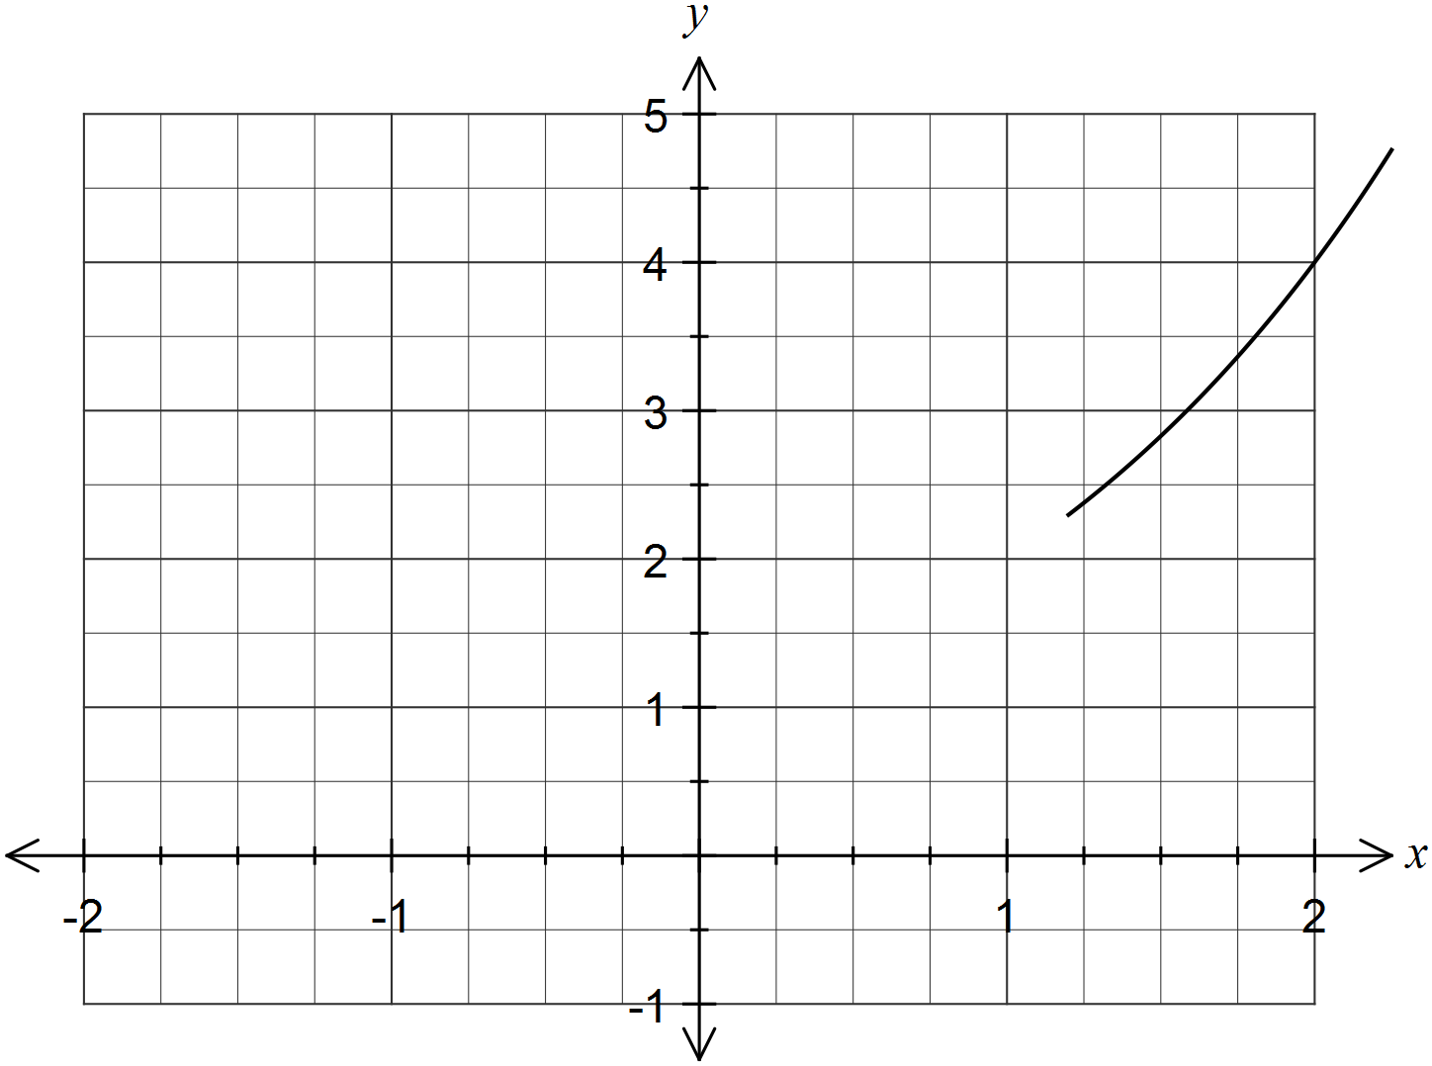

(a) Complete the graph of . (2 marks)

(b) Use the graph to solve . (1 mark)

(c) Use the graph to explain why  has no solutions. (1 mark)

Question 9 (7 marks)

The project network below consists of 16 tasks, with completion times shown in days.

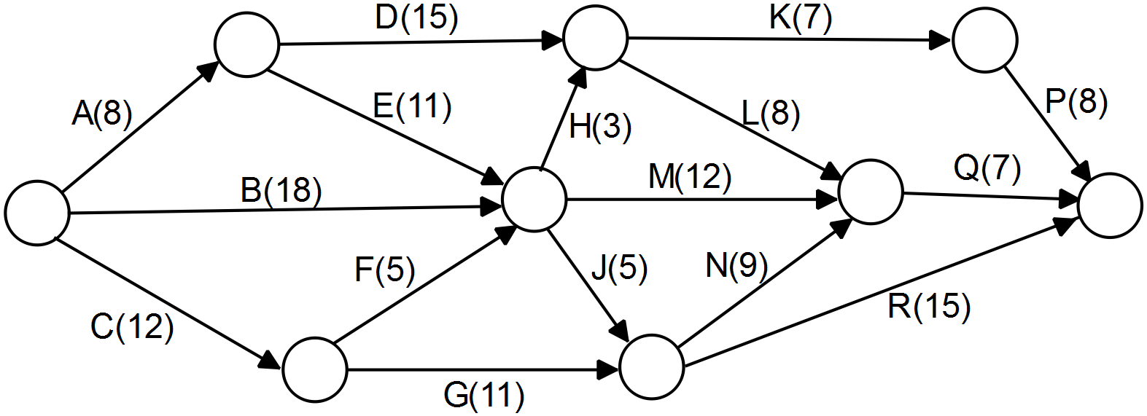

(a) List, in order, the tasks on the critical path and determine the minimum completion time for this project. (3 marks)

(b) The time to complete task F increases by four days. Determine the effect, if any, on your answers to part (a). (2 marks)

(c) An additional task that is not a predecessor for any other task, is to be added to the network and can commence once task D is complete. How many days can this new task be allocated without increasing the minimum completion time? (2 marks)

Question 10 (8 marks)

The scores of 22 students in a test out of 50 are listed below in ascending order.

13, 16, 20, 21, 22, 23, 25, 27, 27, 30, 31,

33, 33, 34, 34, 35, 35, 37, 38, 40, 41, 45

(a) Construct a boxplot for these scores. (3 marks)

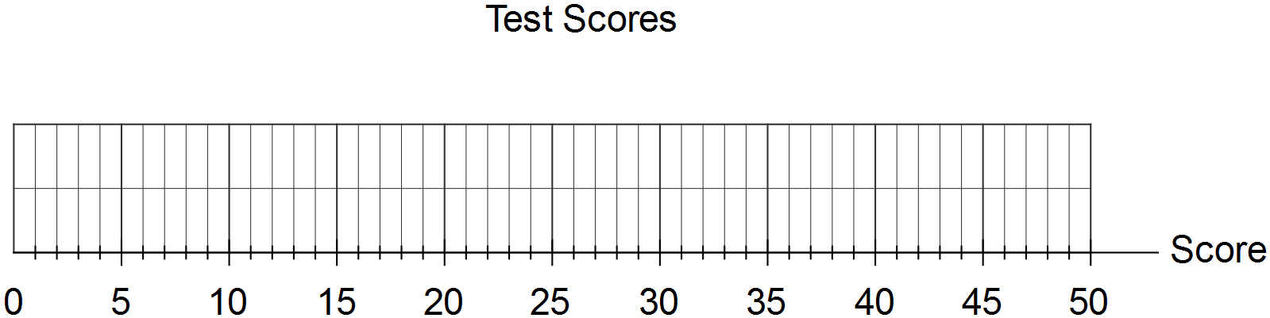

(b) The lowest score in the dataset can be decreased by n, where n is an integer, so that the score becomes an outlier. Determine the minimum possible value of n. (3 marks)

(c) If all scores less than 20 were cropped from the set of data, state the effect (decrease, increase or stay the same) this would have on the following summary statistics:

(i) the mean. (1 mark)

(ii) the standard deviation. (1 mark)

Question 11 (11 marks)

The graph below shows the average number of cigarettes smoked per week by smokers aged 18 to 24 for the years 1980 to 2010.

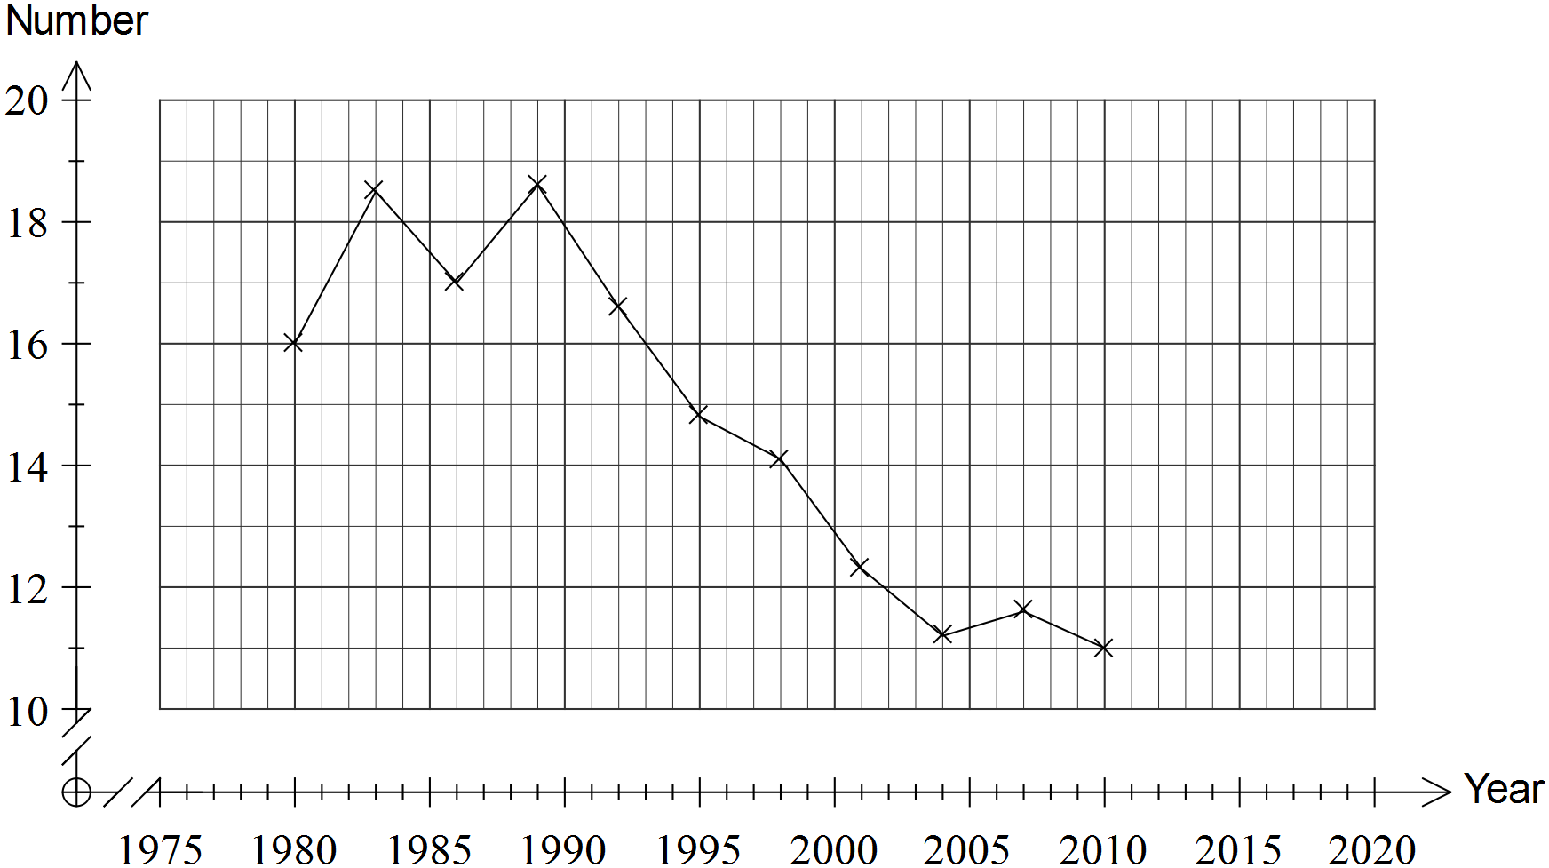

The table below shows the same data for 1989 to 2010.

|  |  |  |  |  |  |  |  |  |
| --- | --- | --- | --- | --- | --- | --- | --- | --- |
| Year, x | 1989 | 1992 | 1995 | 1998 | 2001 | 2004 | 2007 | 2010 |
| Number, y | 18.6 | 16.6 | 14.8 | 14.1 | 12.3 | 11.2 | 11.6 | 11 |

(a) For the data in the table, determine

(i) the correlation coefficient . (1 mark)

(ii) the least squares regression model, giving coefficients rounded to five significant figures. (2 marks)

(b) Describe how your answers in (a) would be affected if all the data shown in the graph was used rather than the cropped data in the table. (2 marks)

(c) Calculate the residual number for 2010 using the regression model from (a) and plot this residual on the graph below. Show all your working. (3 marks)

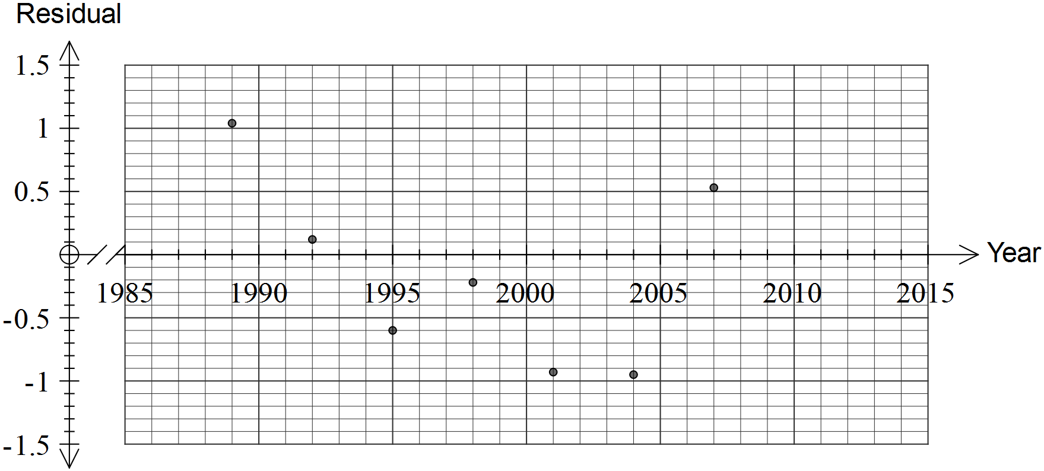

(d) Use the regression model from (a) to predict the average number of cigarettes smoked per week by smokers aged 18 to 24 in the year 2015. (1 mark)

(e) Comment on the reliability of the prediction in (d). (2 marks)

Question 12 (7 marks)

The function  is shown below.

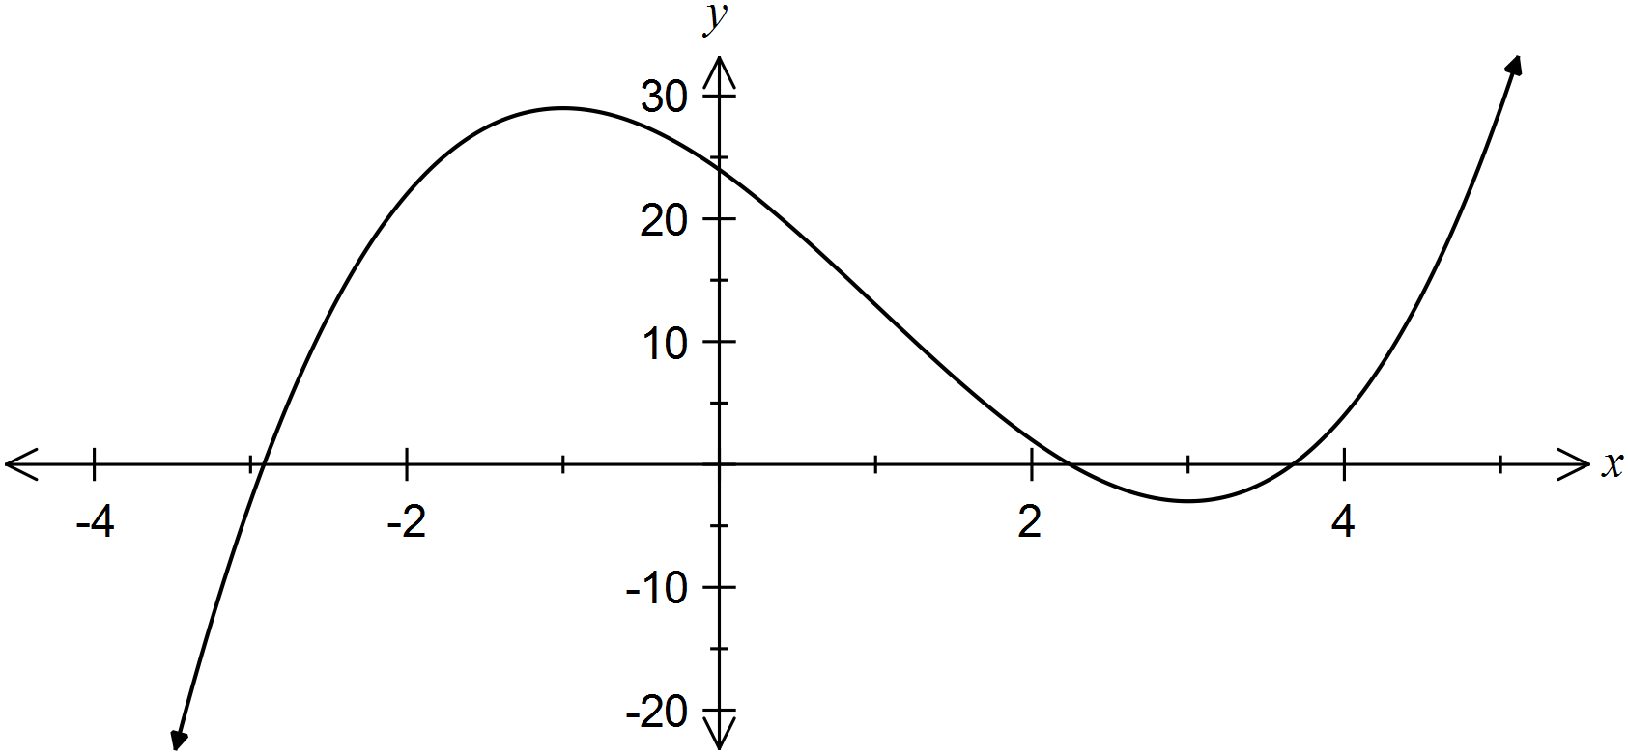

(a) Determine  for this function. (1 mark)

(b) Determine the equation of the tangent to the curve when , and draw it on the axes above. (3 marks)

(c) Use a calculus method to determine the coordinates of the turning points of the curve.

(3 marks)

Question 13 (7 marks)

The relationship between two variables, t and s, is shown in the table below.

|  |  |  |  |  |  |
| --- | --- | --- | --- | --- | --- |
| t | 2 | 4 | 5 | 8 | 10 |
| s | 100 | 50 | 40 | 25 | 20 |

(a) Describe what happens to the value of s when t doubles. (1 mark)

(b) Describe the type of proportionality that exists between the two variables. (1 mark)

(c) Write an equation for s in terms of t. (2 marks)

(d) Sketch the relationship between s and t on the axes below. (3 marks)

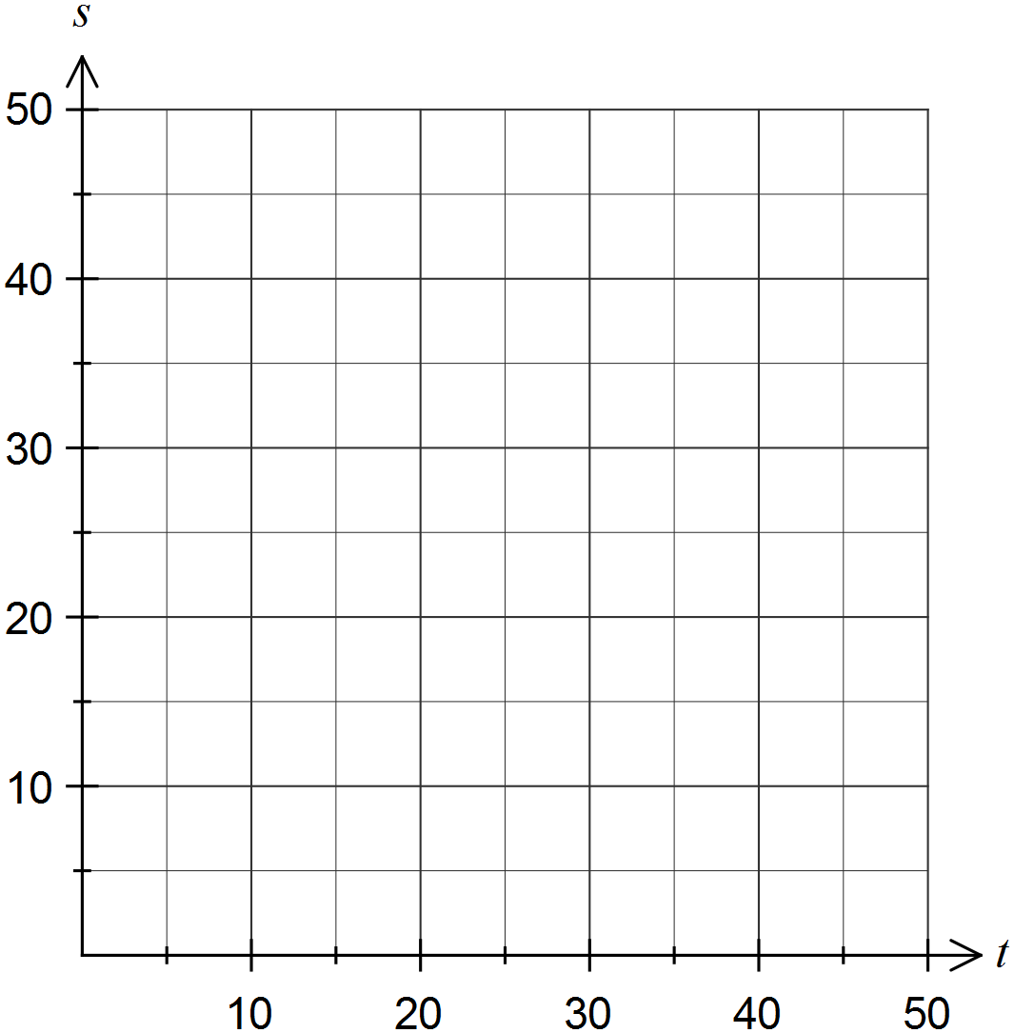

Question 14 (8 marks)

Trapezium ABCD below has parallel sides AD and BC. The lengths of BC and CD are 12 cm and 20 cm respectively, the length of the diagonal BD is 26 cm and the size of angle BAD is 50º.

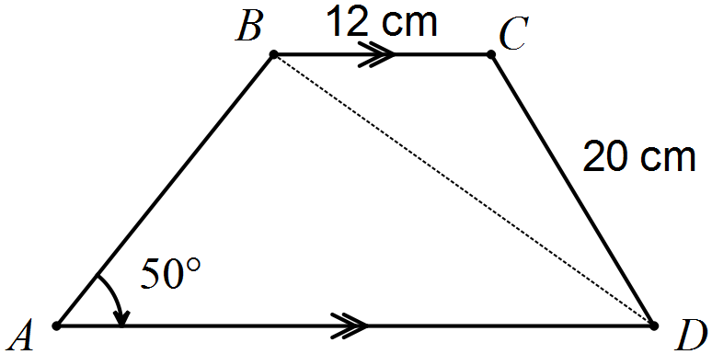

Determine

(a) The size of angle CBD. (2 marks)

(b) The length of side AB. (3 marks)

(c) The area of the trapezium ABCD. (3 marks)

Question 15 (9 marks)

To save money towards a deposit on a house, Anh and Bo started an investment account. They made an initial deposit of $3 700, and then deposited an extra $850 at the end of each month for the next year. Interest on the account was payable monthly.

The table below shows the progress of their savings for the first few months.

|  |  |  |  |  |
| --- | --- | --- | --- | --- |
| Month  () | Balance of account at start of month () | Interest added at end of month | Deposit made at end of month | Balance of account at end of month () |
| 1 | $3 700.00 | $14.80 | $850.00 | $4 564.80 |
| 2 | $4 564.80 | $18.26 | $850.00 | $5 433.06 |
| 3 | $5 433.06 | $21.73 | $850.00 | $6 304.79 |
| 4 | $6 304.79 | **A** | $850.00 | **B** |

(a) What was the monthly percentage interest rate? (1 mark)

(b) Determine the values of **A** and **B** in the table. (2 marks)

(c) Write a recursive rule to determine the balance of the account at the start of each month.

(2 marks)

(d) Determine, to the nearest dollar, the balance of the account at the start of month 13.

(2 marks)

(e) Calculate, to the nearest dollar, the total interest earned up to the start of month 13.

(2 marks)

Question 16 (9 marks)

A parcel delivery service visits a rural town every Monday, Tuesday, Thursday and Friday in the period leading up to Christmas. The number of parcels delivered on each visit are shown below.

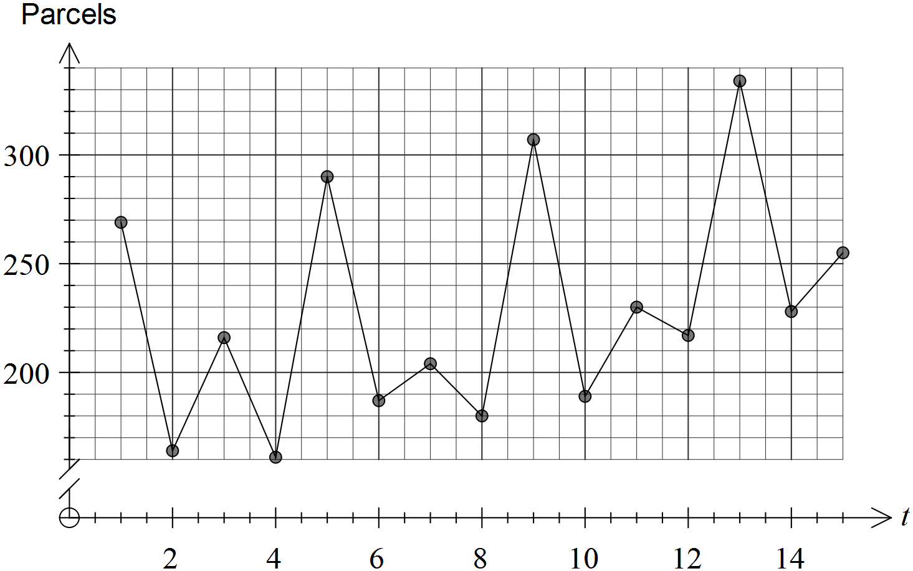

The table below shows the data for the second and third weeks of the delivery service.

|  |  |  |  |
| --- | --- | --- | --- |
| Time (t) | Week | Day | Parcels delivered |
| 4 | 1 | Fri |  |
| 5 | 2 | Mon | 290 |
| 6 | 2 | Tue | 187 |
| 7 | 2 | Thu | 204 |
| 8 | 2 | Fri | 180 |
| 9 | 3 | Mon | 307 |
| 10 | 3 | Tue | 189 |
| 11 | 3 | Thu | 230 |
| 12 | 3 | Fri | 217 |
| 13 | 4 | Mon |  |

(a) What feature of the graph suggests that smoothing the data with a four-point centred moving average would be appropriate? (1 mark)

(b) Calculate the four-point centred moving average for Friday of Week 2. (2 marks)

(c) Determine the residual for Monday of Week 3. (*The residual is the number of parcels delivered minus the moving average, for any given day*.) (2 marks)

(d) All possible residuals that can be calculated from the graphed data for Fridays are -49.63, -39.75 and -30.38. Use these values to determine the seasonal component for Friday.

(1 mark)

(e) The regression model calculated from the data is , where p is the number of parcels delivered. Use the regression model and seasonal component to best estimate the number of parcels delivered on Friday of Week 4. (3 marks)

Question 17 (8 marks)

The moisture content, as a percentage by weight, of timber sold by a company is normally distributed with a mean of 10.6% and a standard deviation of 1.2%.

(a) What proportion of the timber sold will have a moisture content of less than 8%? Give your answer rounded to three significant figures. (2 marks)

(b) What is the probability that a randomly selected piece of timber sold by the company will have a moisture content within 2% of the mean? (2 marks)

(c) Above what percentage of moisture content will just 5% of timber exceed? (2 marks)

(d) As the moisture content of timber increases, so the compressive strength of the timber decreases. A particular builder will only use timber with a moisture content below 12% for structural purposes, with the rest of the timber being used for non-structural purposes.

If this builder buys an assortment of 500 lengths of timber, how many of these lengths of timber will be suitable for structural purposes? (2 marks)

Question 18 (8 marks)

A password is to be made by selecting five different characters from the seven characters in the set { 8, 9, X, Y, Z, $, % }, such as Z%9X8.

(a) Determine the number of different passwords that can be made if

(i) there are no other restrictions. (1 mark)

(ii) the password must not end with a number. (2 marks)

(iii) the first three characters of the password must be letters. (2 marks)

(b) Determine the probability that a randomly selected password

(i) does not end with a number. (1 mark)

(ii) has letters as the first three characters and does not end with a number. (2 marks)

Question 19 (6 marks)

(a) A conjecture was made that all the terms of the sequence given by  for all positive integers n, are divisible by five.

State whether or not the conjecture is true. Justify your answer. (3 marks)

(b) Prove that the difference of any two odd numbers is always even. (3 marks)

Question 20 (8 marks)

A 66 cm length of wire is to be bent into the shape below, where all adjacent sides of the shape are perpendicular to each other.

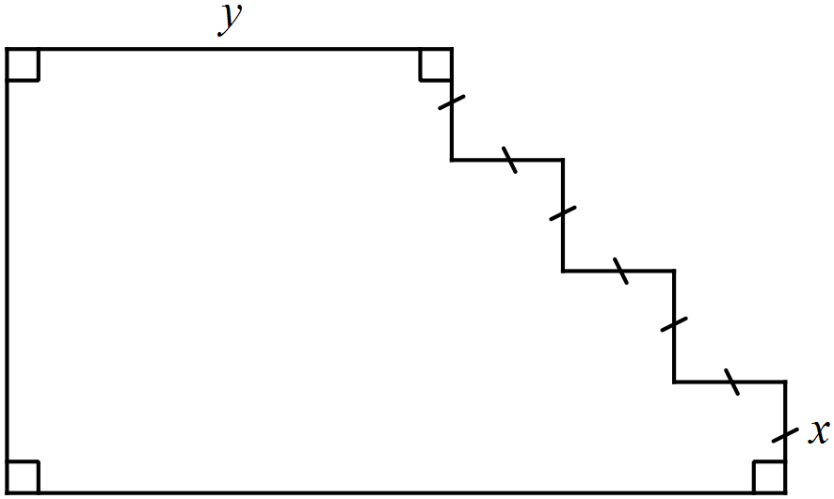

(a) If  cm, determine the area of the shape. (2 marks)

(b) By considering the perimeter of the shape, show that . (1 mark)

(c) Show that the area of the shape is given by . (2 marks)

(d) Use calculus techniques to determine the maximum possible area of the shape.

(3 marks)

Additional working space

Question number: _________

Additional working space

Question number: _________

This examination paper may be freely copied, or communicated on an intranet, for non-commercial purposes within educational institutes that have purchased the paper from WA Examination Papers provided that WA Examination Papers is acknowledged as the copyright owner. Teachers within Rossmoyne Senior High School may change the paper provided that WA Examination Paper's moral rights are not infringed.

Copying or communication for any other purposes can only be done within the terms of the Copyright Act or with prior written permission of WA Examination papers.

*Published by WA Examination Papers*

*PO Box 445 Claremont WA 6910*